# 

# ASSIGNMENT – 1

# OPERATING SYSTEM LAB – WORK

**Name:** Aryan Shukla

**Roll No. :** 2301410018

**Course:** BTech CSE (cyber security)

# Task 1: Process Creation Utility

Write a Python program that creates N child processes using os.fork(). Each child prints:

* Its PID
* Its Parent PID
* A custom message

The parent should wait for all children using os.wait().

**CODE:**

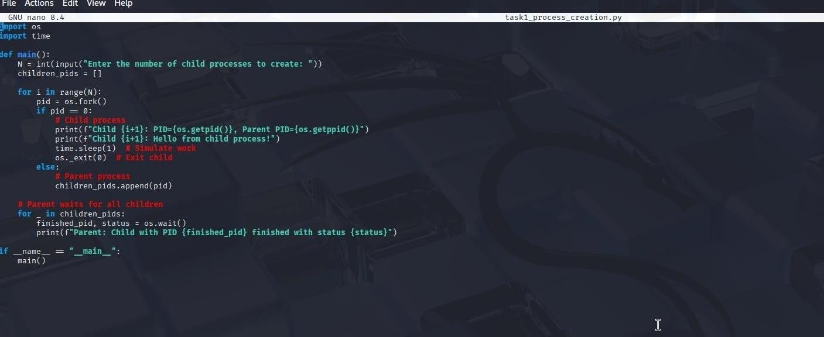

# OUTPUT

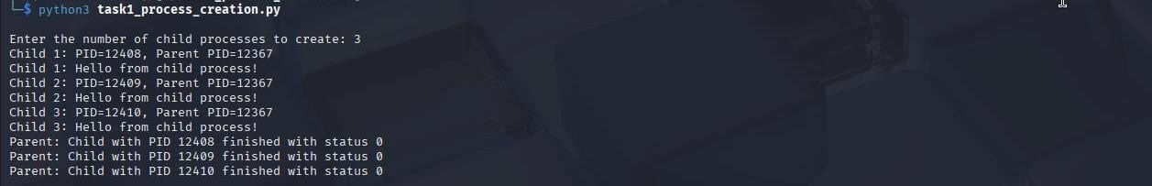

## Command Execution Using exec()

Modify Task 1 so that each child process executes a Linux command (ls, date, ps, etc.) using os.execvp() or subprocess.run().

**CODE:**

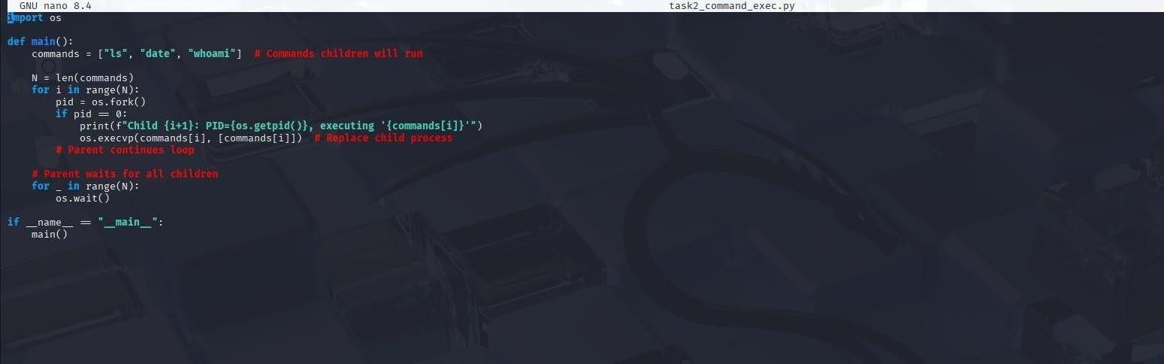

# OUTPUT



## Zombie & Orphan Processes

**Zombie:** Fork a child and skip wait() in the parent.

**Orphan:** Parent exits before the child finishes. Use ps -el | grep defunct to identify zombies.

# CODE

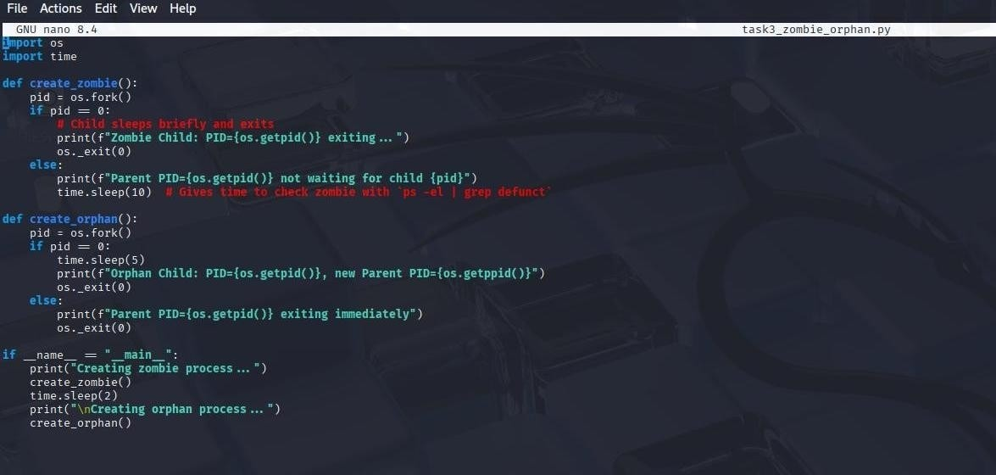

# OUTPUT

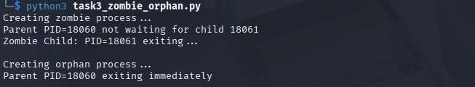



**Inspecting Process Info from /proc** Take a PID as input. Read and print:

* Process name, state, memory usage from /proc/[pid]/status
* Executable path from /proc/[pid]/exe
* Open file descriptors from /proc/[pid]/fd

# CODE

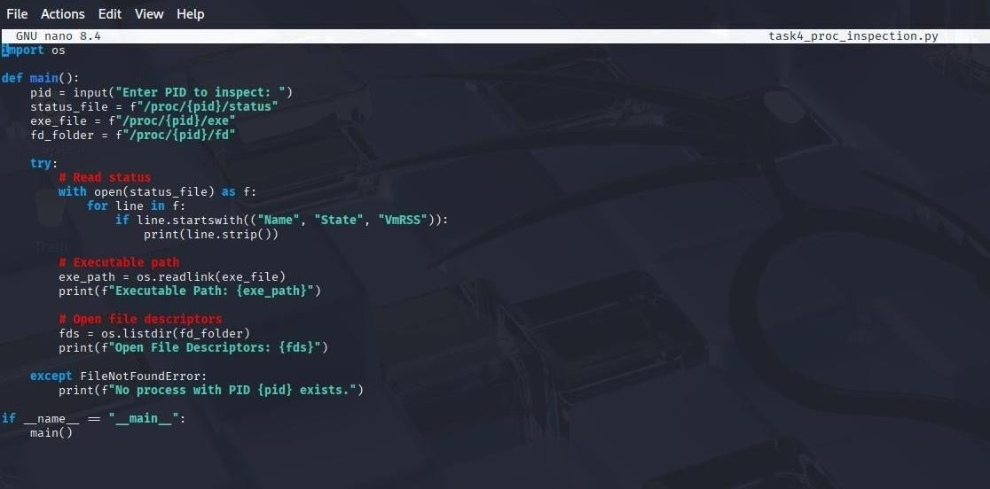

# OUTPUT

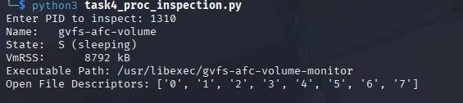

## Process Prioritization

Create multiple CPU-intensive child processes. Assign different nice() values. Observe and log execution order to show scheduler impact.

# CODE

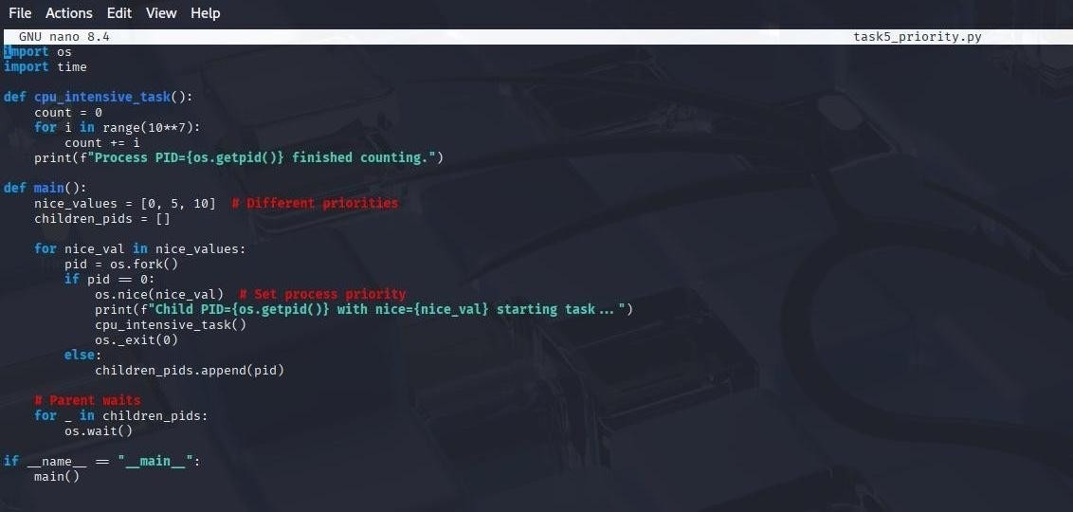

# OUTPUT

